Brett Stelly

Rendering Geometry

**How to generate a half-circle given a number of points and a radius.**

The function for generating a half circle will have a return type of a vector of type vec4 and it will need to take in two ints for parameters. One int for the number of points and the other for the radius of the half circle.



Within this function, you will declare a vector of type vec4 variable. This variable, which I called “points” will store the points generated to create the half circle.



Next, create a for loop. The for loop initializes a variable of type float and assigns it zero. The condition is that the variable is less than the number of points passed into the function. The variable should increment by one each iteration of the loop.

Within the for loop, declare a new float called angle, and assign it pi divided by the number of points minus one. Next, create another float called theta and assign it the for loop’s variable multiplied by angle. Finally, push back a new ve4 onto the points vector. The vec4’s x value will be the cosine of theta multiplied by the radius passed in. The vec4’s y value will be the sine of theta multiplied by the radius. The last two values will be zero and one respectively.

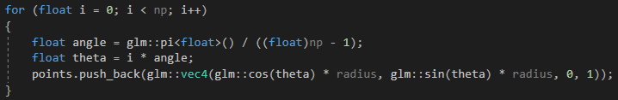

After the for loop runs, the function will return the points vector.

**Finished code:**

